Mid Pennine Arts
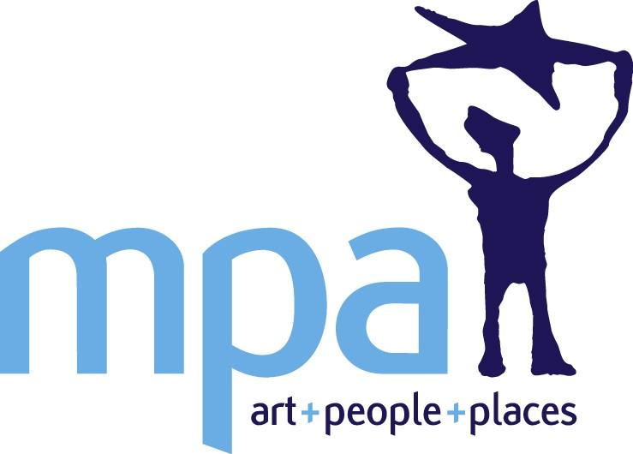
Friends Membership Form

PLEASE ADD DETAILS THIS SIDE

IN BLOCK CAPITALS
Category of membership

Surname
First name
Second Full Name
(for Joint Members only)

Organisation Name
(for Non-Profit Orgs & Corporate only)

Address
Postcode

Telephone
Mobile

Email address

Please complete the above form and send it along with a cheque^ for:
£9 (Individual), £6 (Concessionary), £15 (Joint), £25* (NPG), £75* (Corp) made payable to Mid Pennine Arts to:

Mid Pennine Arts
1 Neptune Street
Weavers’ Triangle
Burnley
BB11 1SF

* please let us know if you require a vat invoice or receipt

